**Lab 4 *- HELLO TOAST***

**Layout Code**

<?xml version="1.0" encoding="utf-8"?>  
<android.support.constraint.ConstraintLayout xmlns:android="http://schemas.android.com/apk/res/android"  
 xmlns:app="http://schemas.android.com/apk/res-auto"  
 xmlns:tools="http://schemas.android.com/tools"  
 android:id="@+id/toast"  
 android:layout_width="match_parent"  
 android:layout_height="match_parent"  
 tools:context=".MainActivity">  
  
 <Button  
 android:id="@+id/button_toast"  
 android:layout_width="0dp"  
 android:layout_height="wrap_content"  
 android:layout_marginStart="8dp"  
 android:layout_marginLeft="8dp"  
 android:layout_marginTop="4dp"  
 android:layout_marginEnd="8dp"  
 android:layout_marginRight="8dp"  
 android:background="@color/purple_500"  
 android:text="@string/button_label_toast"  
 android:textAllCaps="true"  
 android:textAppearance="@style/TextAppearance.AppCompat.Large"  
 android:textColor="@color/white"  
 android:textStyle="bold"  
 app:layout_constraintEnd_toEndOf="parent"  
 app:layout_constraintHorizontal_bias="0.0"  
 app:layout_constraintStart_toStartOf="parent"  
 app:layout_constraintTop_toTopOf="parent"  
 android:onClick="showToast"/>  
  
 <Button  
 android:id="@+id/button_count"  
 android:layout_width="0dp"  
 android:layout_height="wrap_content"  
 android:layout_marginStart="8dp"  
 android:layout_marginLeft="8dp"  
 android:layout_marginEnd="8dp"  
 android:layout_marginRight="8dp"  
 android:layout_marginBottom="8dp"  
 android:background="@color/purple_500"  
 android:text="@string/button_label_count"  
 android:textAllCaps="true"  
 android:textAppearance="@style/TextAppearance.AppCompat.Large"  
 android:textColor="#FFFFFF"  
 android:textStyle="bold"  
 app:layout_constraintBottom_toBottomOf="parent"  
 app:layout_constraintEnd_toEndOf="parent"  
 app:layout_constraintStart_toStartOf="parent"  
 android:onClick="countUp" />  
  
 <TextView  
 android:id="@+id/show_count"  
 android:layout_width="0dp"  
 android:layout_height="0dp"  
 android:layout_marginStart="8dp"  
 android:layout_marginLeft="8dp"  
 android:layout_marginTop="8dp"  
 android:layout_marginEnd="8dp"  
 android:layout_marginRight="8dp"  
 android:layout_marginBottom="8dp"  
 android:background="#FFFF00"  
 android:gravity="center_horizontal|center_vertical"  
 android:text="@string/count_initial_value"  
 android:textAppearance="@style/TextAppearance.AppCompat.Large"  
 android:textColor="#3F51B5"  
 android:textIsSelectable="false"  
 android:textSize="160sp"  
 android:textStyle="bold"  
 app:layout_constraintBottom_toTopOf="@+id/button_count"  
 app:layout_constraintEnd_toEndOf="parent"  
 app:layout_constraintStart_toStartOf="parent"  
 app:layout_constraintTop_toBottomOf="@+id/button_toast" />  
</android.support.constraint.ConstraintLayout>

**JAVA Code**

package com.example.hellotoast;  
  
import android.support.v7.app.AppCompatActivity;  
import android.os.Bundle;  
import android.view.View;  
import android.widget.TextView;  
import android.widget.Toast;  
  
public class MainActivity extends AppCompatActivity {  
  
 private int mCount = 0;  
 private TextView mShowCount;  
  
 @Override  
 protected void onCreate(Bundle savedInstanceState) {  
 super.onCreate(savedInstanceState);  
 setContentView(R.layout.*activity_main*);  
 mShowCount = (TextView) findViewById(R.id.*show_count*);  
 }  
  
 public void showToast(View view) {  
 Toast toast = Toast.*makeText*(this, R.string.*toast_message*,Toast.*LENGTH_SHORT*);  
 toast.show();  
 }  
  
 public void countUp(View view) {  
 mCount++;  
 if (mShowCount != null) {  
 mShowCount.setText(Integer.*toString*(mCount));  
 }  
 }  
}

**Manifest File**

<?xml version="1.0" encoding="utf-8"?>  
<manifest xmlns:android="http://schemas.android.com/apk/res/android"  
 package="com.example.hellotoast">  
  
 <application  
 android:allowBackup="true"  
 android:icon="@mipmap/ic_launcher"  
 android:label="@string/app_name"  
 android:roundIcon="@mipmap/ic_launcher_round"  
 android:supportsRtl="true"  
 android:theme="@style/Theme.HelloToast">  
 <activity android:name=".MainActivity">  
 <intent-filter>  
 <action android:name="android.intent.action.MAIN" />  
  
 <category android:name="android.intent.category.LAUNCHER" />  
 </intent-filter>  
 </activity>  
 </application>  
  
</manifest>

**Output Screenshots**

1. **Initial Screen**

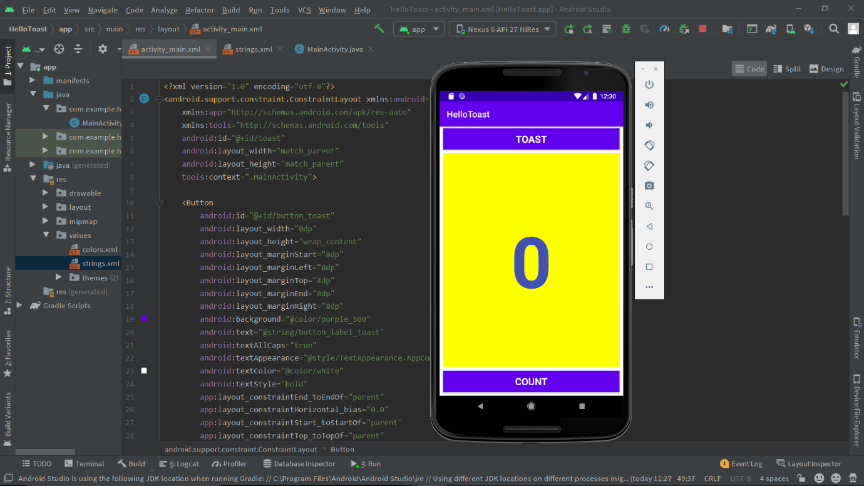

1. **Toast Button Click**

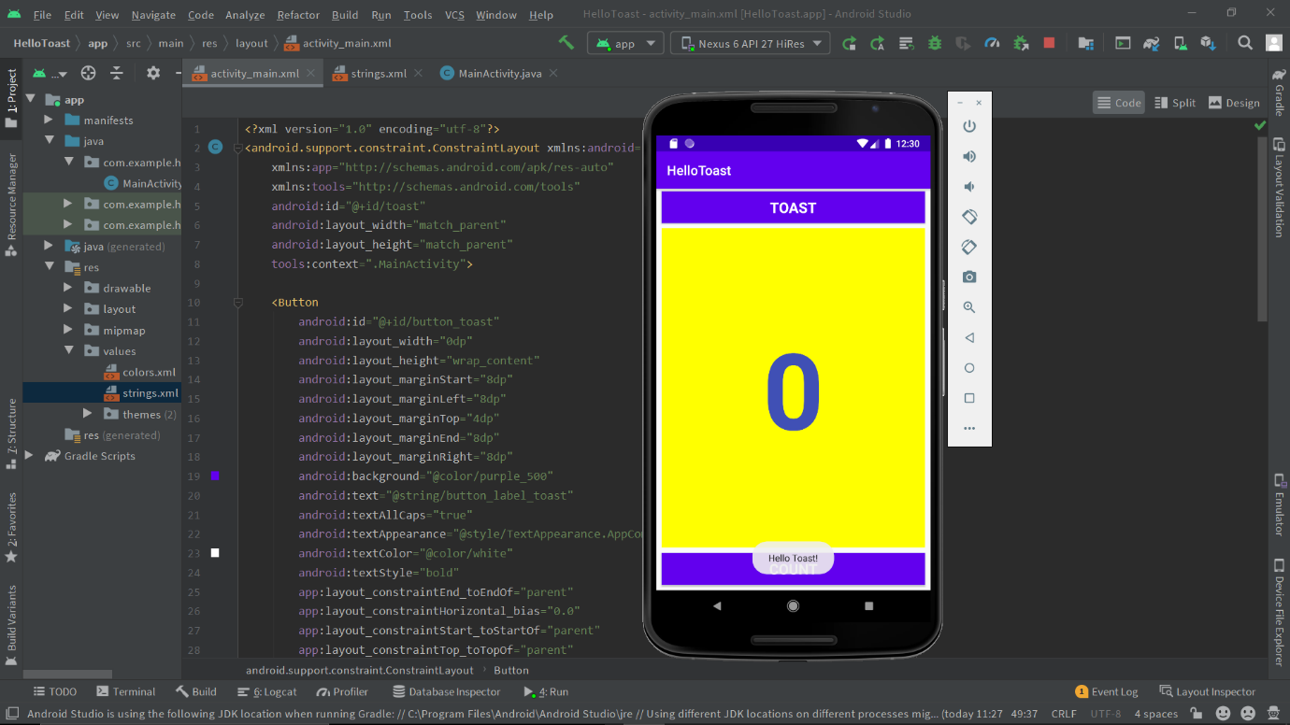

1. **Count Button Clicks**

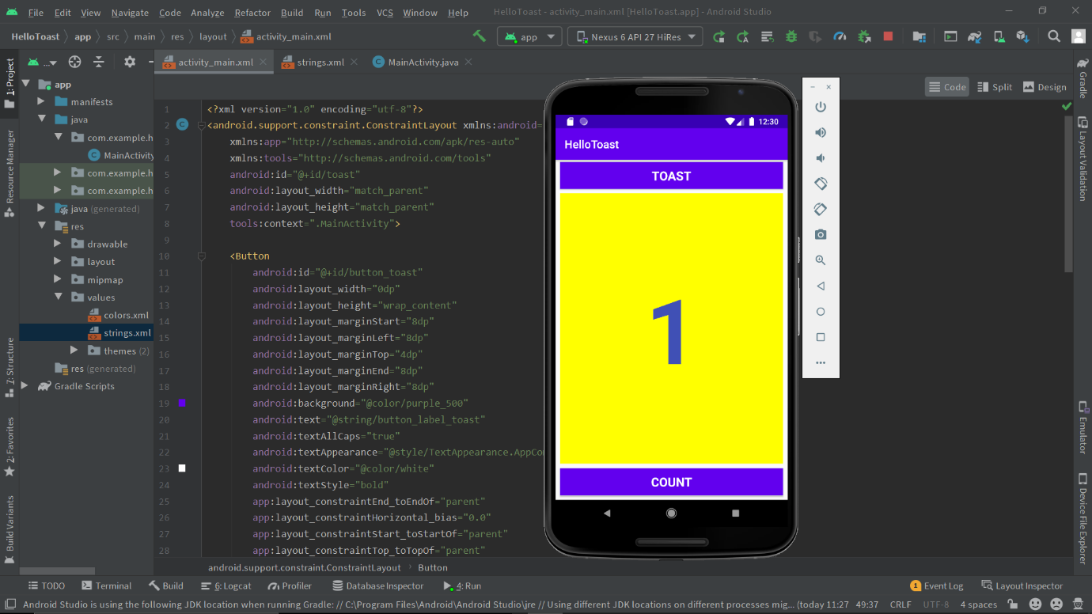

**After Few Clicks…**

